**DevOps Certification Training**

Lab Guide

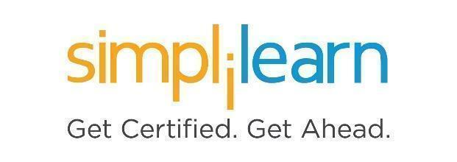

**Note: The screenshots used in Step 1 are only for your reference. Your LMS may look different depending on your course content.**

This section will guide you to:

* Use labs for executing all the demos included in this course

This lab has two subsections, namely:

1. Starting practice labs on LMS
2. Using different IDEs and software required for this course

**Step 1:** Starting **Practice Labs** on LMS

* Log in the Simplilearn LMS
* Go to the respective course

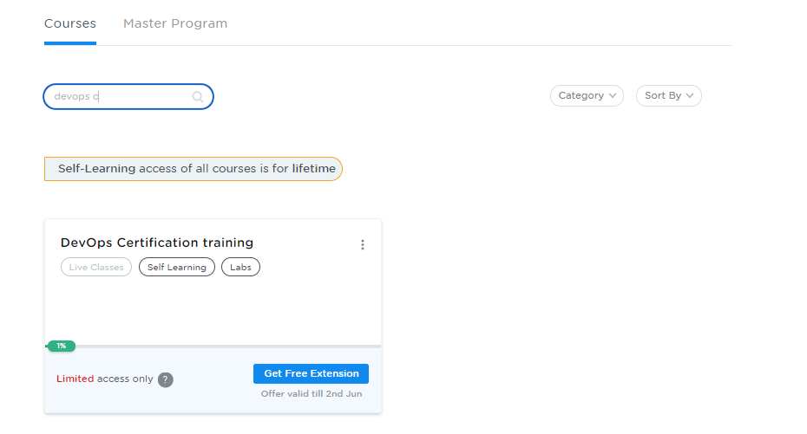

* You will see the course TOC page, click on **PRACTICE LABS**.

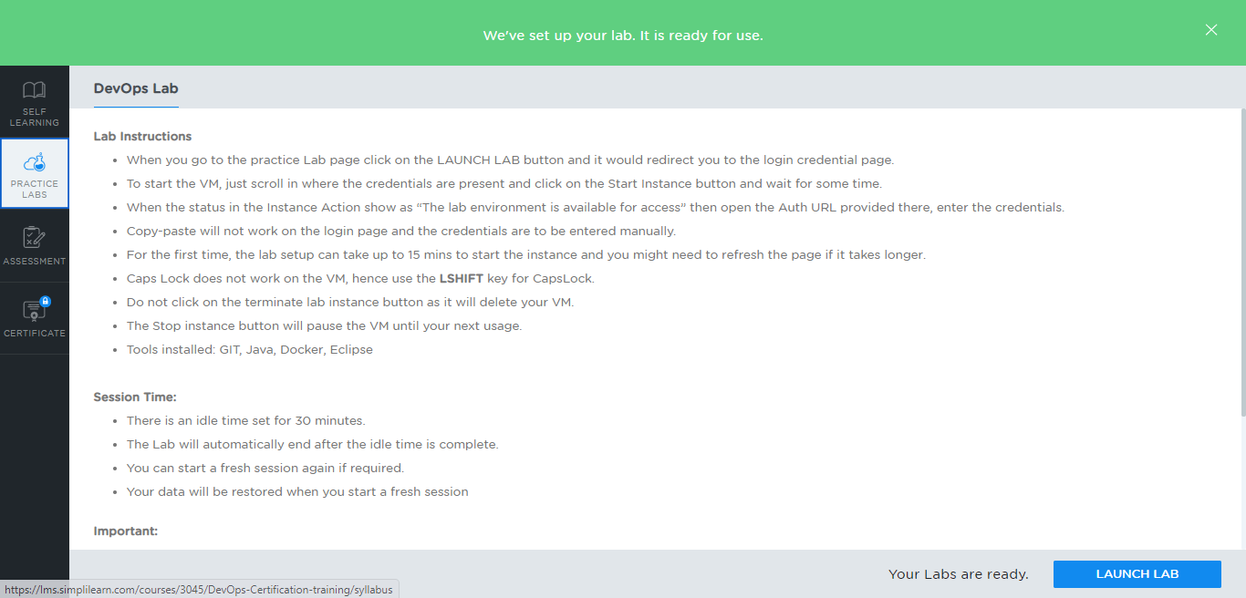

* A new window will open. Read the instructions and click on the **LAUNCH LAB** button**.** This will launch the practice labs for this course.
* In the next window, click on the **Auth URL**, which will direct you to the DevOps console in a new browser tab

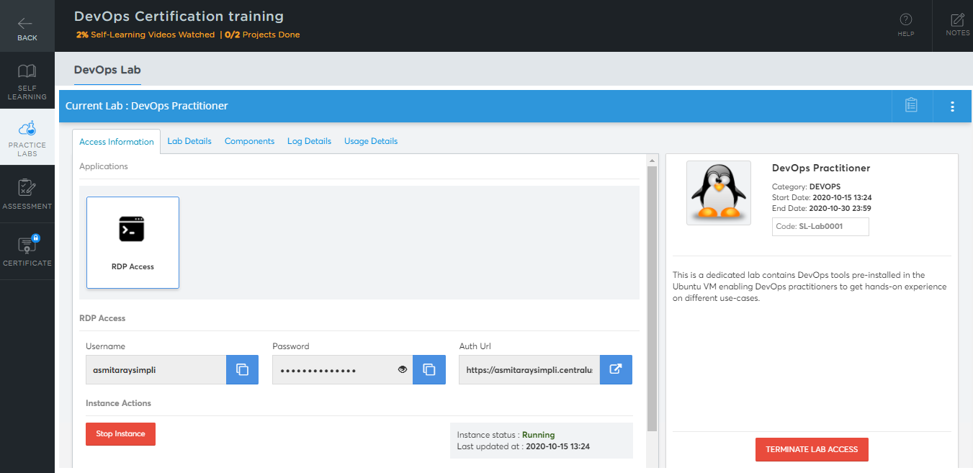

* In the newly opened tab, you need to provide the login credentials to get started.

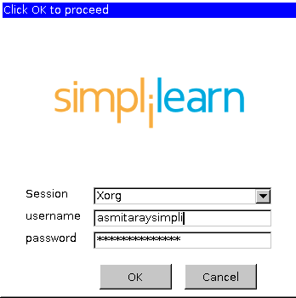

* You will be able to access the required services and resources in this console.

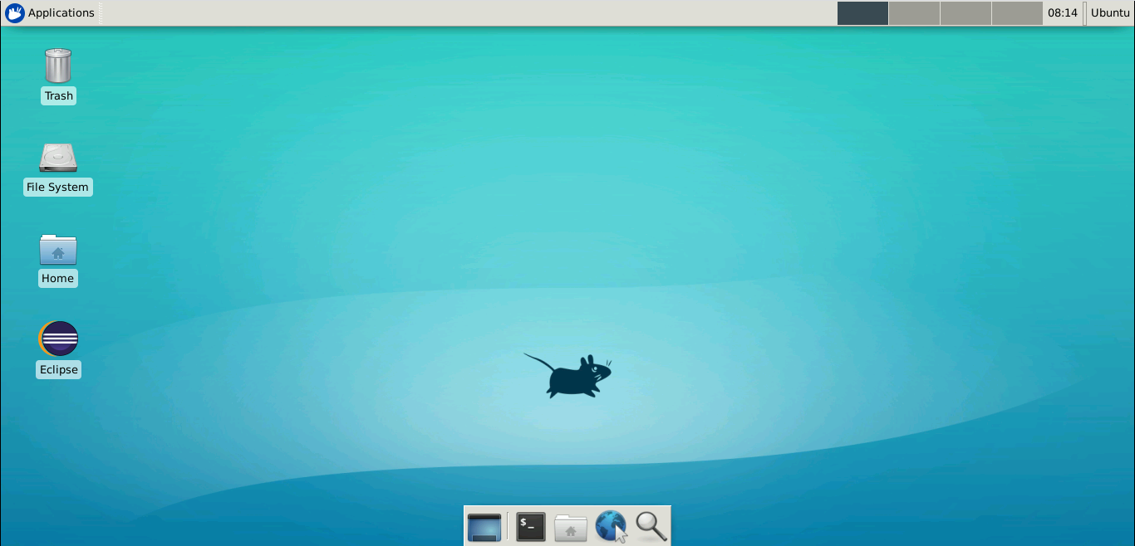

**Step 2:** Using different IDEs and software required for this course

* Eclipse:
* Check the default box
* Click on the Launch button

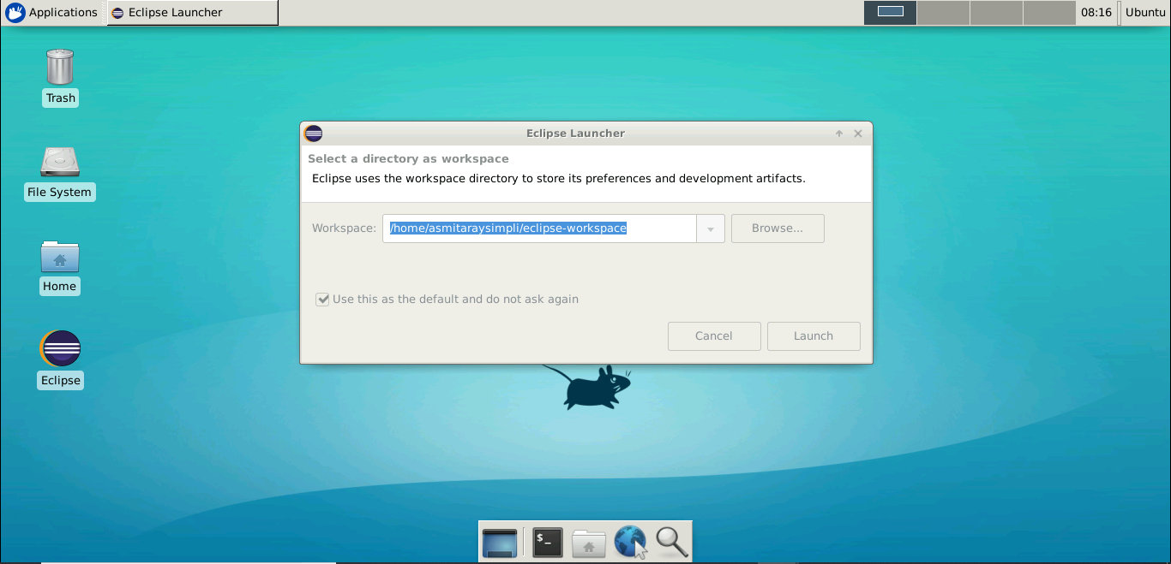

* **Git:**
* Git is already installed in the labs.
* To check whether Git is installed properly or not run the following commands:
  + - **git --version**
    - **git –exec-path**
    - **git init**

